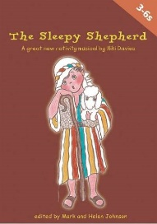
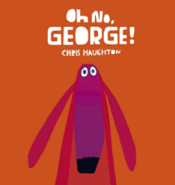
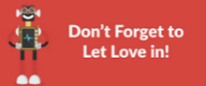
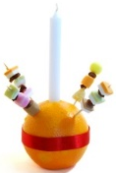
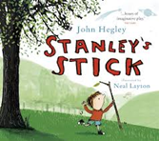
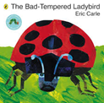
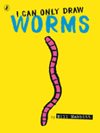

PE
We are going on a space adventure this half term! In this unit, the children will develop our jumping and landing skills. We will also practise our seated balance. We will be doing some calming, body stretching YOGA.
English
Writing
We will continue with our focus on handwriting, sentence structure and skills this half term through our new texts. ‘I can only draw worms’ will allow us to generate adjectives to use in descriptive captions. ‘Oh no, George!’ will let us learn the skill of adding –ed to the end of a word to write about what is happening in the dark. ‘The Bad-Tempered Ladybird’ will also help us use –ed to show how the ladybird was talking when she was cross. And Stanley’s stick will introduce using ‘and’ to join two imaginative ideas together.
Reading
We will be learning new sounds and tricky words in our daily phonics sessions and applying these new skills to help us read more fluently.
We will be developing our comprehension skills to be able to talk about the books we read in more detail.
Spelling
We will have weekly spelling quizzes based on the sounds we have learnt the previous week and our new tricky words.

Year 1 | Autumn 2 | 2026
Use Your Imagination
This half term our text drivers are:

Maths
During this half term we will be exploring numbers using the part whole model and the five and a bit structure. We will also be looking at where numbers lie on a number line and why.
We will explain what odd and even numbers are and explain the differences between them.
We will also look at how odd and even numbers can be partitioned and how to work systematically when partitioning numbers 6-10.
Art
This half term we will be looking at colour. We will match colours to objects, find collections of colour and learn how to make tones of secondary colours.
We will then apply colour with a range of tools and explore brush strokes (watercolour wash, sweep, dab, bold brushstroke)

Geography
We will be looking at where we live and what countries make up The United Kingdom. We will also begin our seasonal weather watching and record what autumn is like.
RE — Light as a Symbol
We will be thinking about how light is a symbol for ourselves and what it means to us and others. We will learn about Christmas and the Jewish festival of Hanukah
and how candles are
important in these
festivals.
PSHE—HeartSmart
This half term we are thinking
about the first principle…
‘Don’t Forget to Let Love in!’- learning to love and value yourself.
History
We will be looking at events beyond living memory as we learn about Guy Fawkes. We will explore artefacts and what they might have been used for. We will learn about the events leading up to the Gunpowder Plot and how we remember them now.
We will also take time to think about and commemorate Remembrance Day.
Computing
We will explore using the BeeBots to do simple instructions and coding. We will learn to organise and debug algorithms when using the BeeBots.
Science
We will explore the parts of the human body and learn how to label them. We will explore the 5 senses and which body parts they link to. We will have some fun doing taste and smell tests.
We can’t wait to share our nativity with you this December!

