Year 1 Long Term Overview - 2026/2027
 | Autumn 1 – 7 weeks & 2 days  New Beginnings | Autumn 2 – 7 weeks  Use Your Imagination | Spring 1 - 6 weeks  Our Unusual Pet | Spring 2 – 5 weeks  Traditional tales | Summer 1 – 7 weeks  Marchwood and Beyond | Summer 2 – 6 weeks & 3 days  The Great Outdoors
 | Text 1 | Text 1 | Text 1 | Text 1 | Recount – Local Walk | Text 1
 |  |  |  | 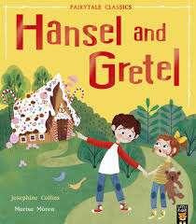 | 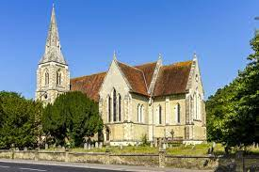 | 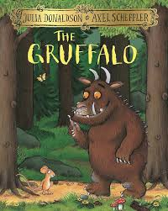
 | Text 2 | Text 2 | Text 2 | Text 2 | Text 2 | Recount – School Trip
 | 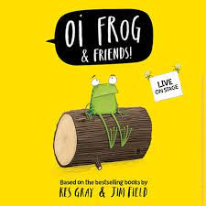 |  |  |  | 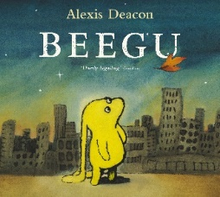 | 
 | Text 3 | Text 3 | Text 3 | Text 3 | Text 3 | Text 2
 |  | 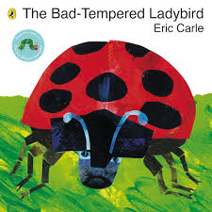 | 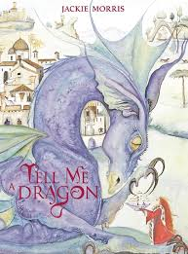 | 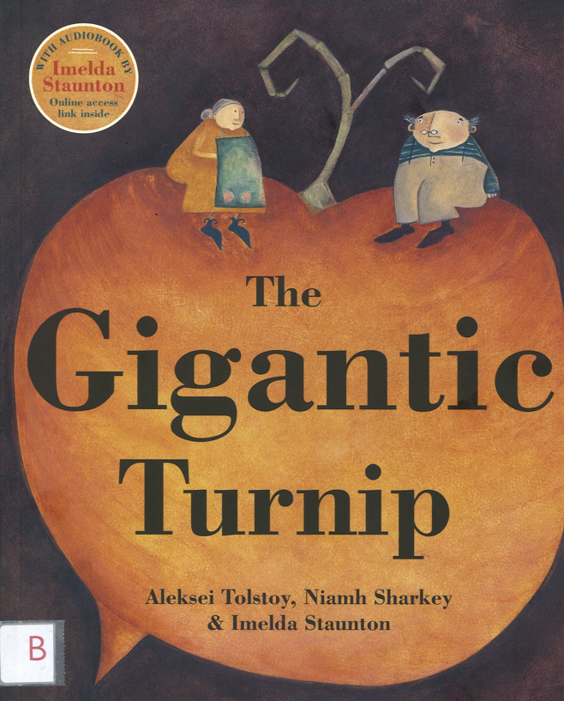 | 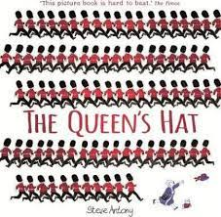 | 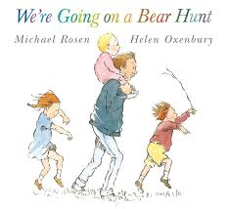
 | Text 4 | Text 4 | Text 4 |  | Text 4 | Text 3
 |  | 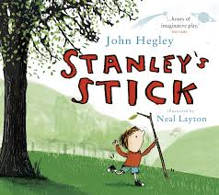 | 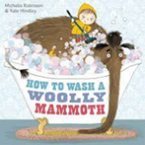 |  | 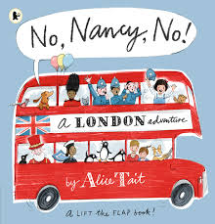 | 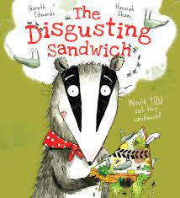
 | Simple recall - School Trip | Nativity Performance
 |  | 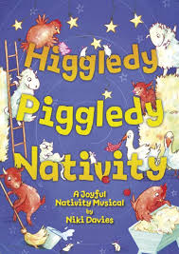
Maths | Block 1 – Place Value within 10  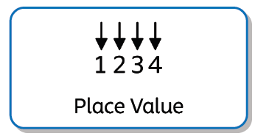  Block 2 – Addition and Subtraction within 10   | Block 2 – Addition and Subtraction within 10 (cont)  Block 3 – Geometry: shape   | Block 4 – Place Value within 20  Block 5 – Addition and Subtraction within 20 | Block 6 – Place Value within 50  Block 7 – Place Value within 100  Block 8 – Money   | Block 9 – Multiplication and Division    Block 10 – Fractions    Block 11 – Geometry: Position & Direction  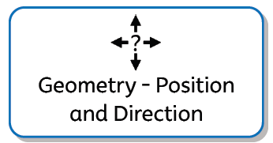  Block 12 – Time   | Block 12 – time (cont)  Block 13 – Length & Height  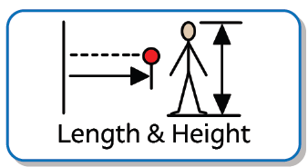  Block 14 – Mass & Volume  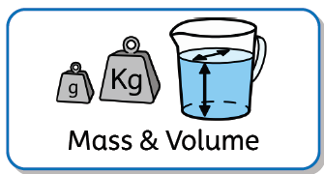
Science | Seasonal Changes  Autumn  Animals, including Humans  Introduction to Science and animals  Name and identify a variety of different animals. | Animals Including Humans  The five senses  Identify, name, draw and label basic parts of a human and say which is associated with each sense. | Seasonal Changes  Winter  Animals Including Humans  Animals and what they eat.  Identify and group a variety of common animals based on their diet and structure. | Seasonal Changes  Spring  Plants  Plants and their structures.  Identify and name common plants | Materials  Materials and their properties  I can identify, classify and group a range of materials.  I can test a range of materials. | Seasonal Changes  Summer  Plants  Plants and their structures.  Identify and name common plants/trees  Identify and describe the basic structure of common flowering plants and trees.
RE | Thankfulness  Harvest and Sukkot | Candle Light  Advent and Hanikah | Changes  People Jesus Met | Sadness to Happiness Easter | Special Places  Church | Belonging  Synagogue
Art | Simple line drawing.  Line drawing using different tools.  Adding texture using lines.  (Reference to the work of illustrator Jim Field). | Colour mixing, secondary colours, brush strokes. | Clay –  Imprints, coils, joining, clay tools. |  | Watercolour wash  Landscape  Silhouettes of London | Georgia O’Keefe – pastels
DT | Joining structures  (Designing a hat for bear) |  |  | Make Gingerbread Men |  | Sliding scenes
History  Timeline to be created over the year |  | Bonfire Night and Guy Fawkes - events beyond living memory | Mary Anning- lives of significant individuals |  | Great Fire of London  Events beyond living memory
Geography | Longitudinal Study of Weather patterns Autumn (see Science books) | Where do I live?  The United Kingdom | Longitudinal Study of Weather patterns Winter (see Science books) | Longitudinal Study of Weather patterns Spring (see Science books)  Mapping skills – interpreting a key, following a route and mapping a route. | Physical features of London / Marchwood  Comparison  Urban, rural, physical and human features.  Maps | Longitudinal Study of Weather patterns Summer (see Science books)  Fieldwork
Computing | Save and retrieve  Use ‘Paint’ to create a piece and save. | BeeBots – following instructions | Technology around us  Keyboard and mouse skills | Data and Information – Grouping Data. | Computing systems and networks – Technology around us.  Digital Writing | Introduction to Coding
Music | As cold as ice  Duration and Structure | [Christmas Performance] | The Old Castle  Timbre | [Folk Active visit] |  | Rainbow Fish  Timbre and Pitch
PSHE  My Happy Minds |  |  |  |  | 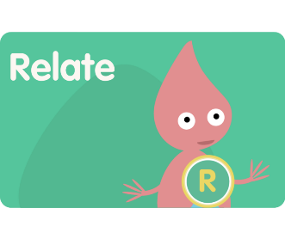 | 
PSHE  Heart Smart |  |  |  |  |  | 
PE | Unit 1: Personal  Footwork/Balance  Apperatus | Unit 2: Social  Jumping/Landing  Seated Balance  Gymnatic Shapes | Unit 3: Cognitive  On a line/Stance  Fitness | Unit 4: Creative  Ball skills/counter balance  Gymnastic Shapes | Unit 5: Physical  Sending/receiving  Reaction/response  Dance: Great Fire of London BBC teach | Unit 6: Health & Fitness  Ball chasing  Multi-games  Sports day
Visitors/  Trips | Marwell Zoo  Harvest Service at Church | Chringle at Church |  | Easter Service at Church  Folk Active visit | Visit to the church and walk around the village. | Hilliers Gardens

